Rejin CNC Introduce
Demo knowledge file for Content Studio | Company profile
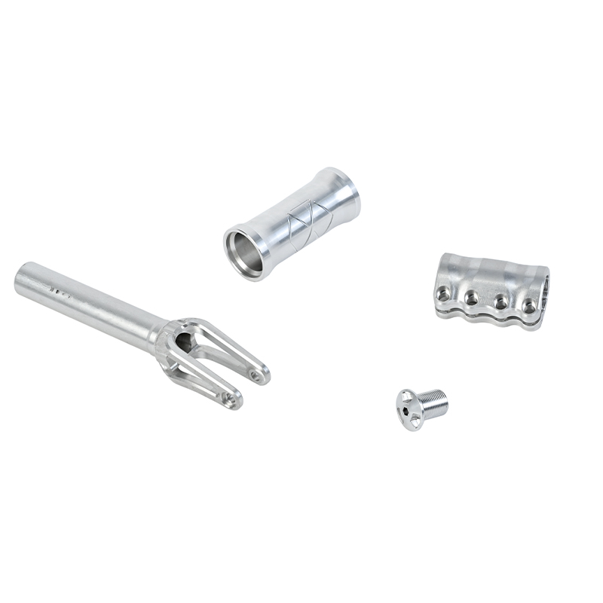
Representative Rejin CNC precision metal part imagery.

Company Overview
Rejin CNC is a China-based precision manufacturing supplier focused on custom CNC machining, sheet metal fabrication, surface finishing, and DFM support for overseas industrial customers.
Factory-direct CNC machining manufacturer providing custom precision parts for global clients. From prototyping to low-volume production with stable quality and fast response. Contact us to discuss your project.

Core Capabilities
- CNC turning, CNC milling, and 5-axis CNC machining for precision metal components.
- Sheet metal fabrication, stamping support, welding, bending, and custom enclosure work.
- Surface treatments such as anodizing, polishing, brushing, painting, and laser engraving.
- DFM and prototype support for teams validating custom part manufacturability before production.

Company Facts
Company | Rejin CNC Technology Co.,Ltd
Website | https://www.rejincnc.com/
Industry | Precision CNC machining and custom metal parts manufacturing
Certifications | ISO 9001:2015; IATF 16949
Target Customers | Overseas procurement teams, mechanical engineers, hardware startups, and supply-chain leads

Reusable Marketing Angles
- Supplier reliability for export-oriented custom metal parts.
- Manufacturing scope from prototype review to low-volume and batch production.
- Quality proof through inspection, certification, and process control messaging.
- Practical RFQ content focused on drawings, materials, tolerances, quantities, finishing, and lead time.

Website Source Notes
Learn about our mission, quality certifications, and expertise as a leading China-based CNC machining manufacturer. Partner with confidence.
Our full-range services include CNC turning, milling, 5-axis, and sheet metal fabrication. Get OEM/ODM solutions for your project.
Source: https://www.rejincnc.com/

